Steps to implement the solution:
- Create Tables
  - Using the DDLs provided, create the tables (FILE_METADATA, COMPARE_FILE_SUMMARY, COMPARE_COLUMN_SUMMARY and COMPARE_COLUMN_DETAIL) in the database.
  - If a non-Oracle database is being used, the syntax of the DDLs may have to be amended as they were formulated on Oracle.

- Import Informatica Objects
  - Select the appropriate folder in the repository
  - Import all the Informatica objects from the XML
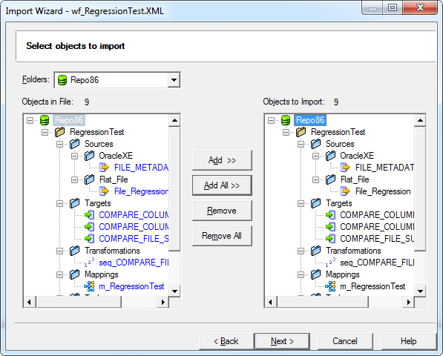

- Build File Metadata
  - Using the attached spreadsheet, create the file metadata insert queries; update only the green cells
  - File ID: Assign a unique integer value
  - File Name: Assign a unique name
  - Column Name: Specify the names in the order they appear in the file
  - Key Flag: Update as Y/N to indicate if column is part of the key
  - Check Flag: Update as Y/N to indicate if non-key column is to compared/ignored.
  - Only non-key columns with Check Flag = ‘Y’ would be compared
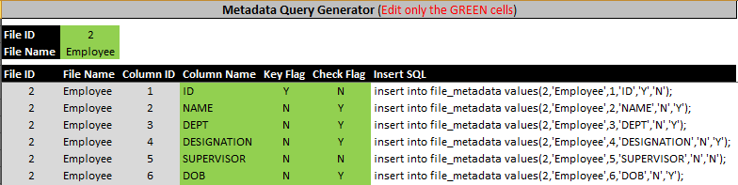

  - Execute the queries against the database; Repeat this process for each set of files to be compared
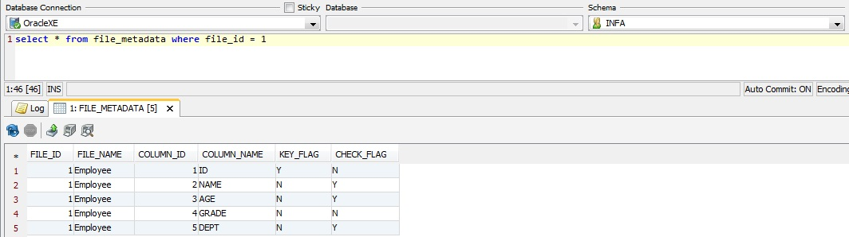

- Amend Workflow
  - Create a session for each set of files to be compared
  - Choose the appropriate delimiter and specify file location

- Execute Workflow
  - On execution, the specified files are compared and the test results are published into the tables COMPARE_FILE_SUMMARY, COMPARE_COLUMN_SUMMARY and COMPARE_COLUMN_DETAIL

- Test Results
  - COMPARE_FILE_SUMMARY: Holds file-level metrics. One row with a unique COMPARE_ID is created for each execution.
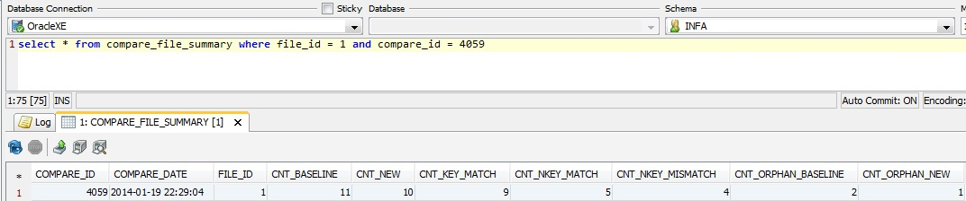

  - COMPARE_COLUMN_SUMMARY: Holds column-level metrics. One row is created for each column on the file.
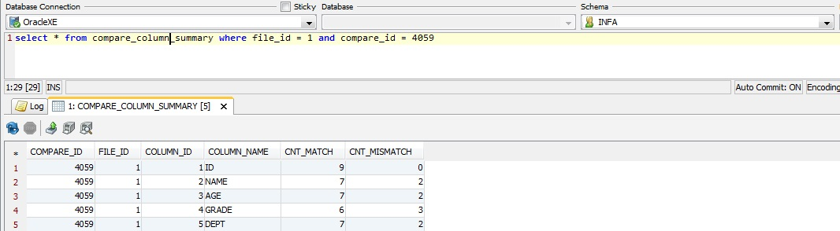

  - COMPARE_COLUMN_DETAIL: Highlights the column value differences. One row is created for each column that differs on each record on the file.
